Client: Holds the secret keys K and has the authority to encrypt, generate search tokens, and decrypt.

Cloud Server: Stores the ciphertext and the encrypted index. The server facilitates data retrieval but remains "blind" to the information.

SSE ALGORITHM:

- Setup - Generate Set Key
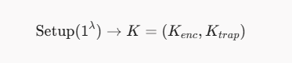
Lambda: Security parameter
K(enc): using function generate key in AESGCM library to create the encryption key

K(trap): The trapdoor key use for the PRF Function to get the token. We get the random chain 32 bytes from the operating system. Otherwise, we use for create index label

- Log Encrypting and Secure Index building

Log encryption: Encrypt the raw data Di to the encrypted version Ci by using block cipher (AES)

Ci = Enc(K(enc), Di)

Di: Raw Data
Ci: Encryption Data
Enc: Encryption Function

Create secure index: Extract trace keywords w like IP, username, filename, use PRF ( HMAC ) Message Authentication Code base on Hashing

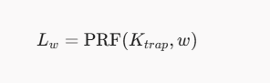

w: keywords data
Ktrap: Key use for PRF function
Lw: The chain result after Hashing keywords data

Structure for Secure Inverted Index:
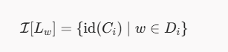
The index entry for label Lw is the set of document IDs id(Ci) corresponding to all documents Di that contain the keyword w.

I: Index structure:
Lw: The label of keywords data ( IP, username, filename … )
id(Ci) | w belongs to Di: id of the encrypted data whose raw data contains w

Output:
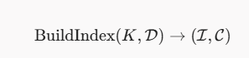

- Create Token - Trapdoor Algorithm

When it is necessary to trace a suspicious keyword w (for example, IP 10.0.0.15), the investigator does not send the keyword in plaintext to the server. Instead, the investigator uses a key Ktrap to execute a PRF function, transforming 10.0.0.15 into a randomized encrypted token string Tw (referred to as a "trapdoor"). This string Tw is then sent to the server.

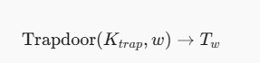

Hashing w using Ktrap to get the Token and then sending the Token to the server

Trapdoor function: Hash MAC

- Searching

If the token is matched with the Label Lw, server send the encryption data Cw corresponding to Lw.

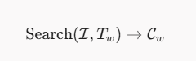

Notice: The server cannot get the Kenc and Ktrap, so the server cannot know exactly the token corresponding to which key, so they cannot read the data

Output:


- Decrypt the data

After get the pcap or log file ( but still encrypted ), the client use the encryption key to get the raw data.

THE PROCEDURE OUTPUT:
